# Steps to find why partition is full and what files can be removed to add free space to it.

1
# See amount of space on all partitions.
df -hT

2
# See what directory is bigger than other in target partition.
du -sh /var/* | sort -hr
# Check /home, /opt/, /var directories first.

3
# Find and sort files that grater than defined or modified today.
echo "$(find /boot -size +100M -exec du -sh {} \;)" | sort -hr
echo "$(find . -not -mtime +1 -type f -exec du -sm {} \;)" | sort -hr

#
# 20180713
#
# To delete busy file, that have large size and release free space on disk drive imedietely - we should do follow.
# This way helps to get free space on hard drive if all free space is run out.
:> path/filename

# 20181014
# How it was.
[root@vm-pgbouncer01p ~]# df -hT /
Filesystem Type Size Used Avail Use% Mounted on
/dev/mapper/vg_root-lvol0 xfs 30G 30G 20K 100% /
[root@vm-pgbouncer01p ~]# ls -Alh /var/log/pgbouncer/pgbouncer.log
-rw-r--r--. 1 pgbouncer pgbouncer 8.1G Oct 14 04:09 /var/log/pgbouncer/pgbouncer.log
[root@vm-pgbouncer01p ~]# :> /var/log/pgbouncer/pgbouncer.log
[root@vm-pgbouncer01p ~]# ls -Alh /var/log/pgbouncer/pgbouncer.log
-rw-r--r--. 1 pgbouncer pgbouncer 691K Oct 14 04:09 /var/log/pgbouncer/pgbouncer.log
[root@vm-pgbouncer01p ~]# df -hT /
Filesystem Type Size Used Avail Use% Mounted on
/dev/mapper/vg_root-lvol0 xfs 30G 22G 8.0G 74% /
[root@vm-pgbouncer01p ~]#

#
# Test for amount of free inodes.

[root@vm-postgresql03t /]# df -i
Filesystem Inodes IUsed IFree IUse% Mounted on
/dev/mapper/vg_root-lvol0 3308160 44916 3263244 2% /
devtmpfs 998617 347 998270 1% /dev
tmpfs 1001313 1 1001312 1% /dev/shm
tmpfs 1001313 483 1000830 1% /run
tmpfs 1001313 16 1001297 1% /sys/fs/cgroup
/dev/sda1 262144 333 261811 1% /boot
tmpfs 1001313 1 1001312 1% /run/user/763
f6290-ds-nfs2:/vol/PGSQL_ibul_msg_pgsys_ds 3112959 96 3112863 1% /pgsys/ibul_msg
f6290-ds-nfs2:/vol/PGSQL_ibul_msg_arch_ds 24903665 23111 24880554 1% /arch/ibul_msg
tmpfs 1001313 1 1001312 1% /run/user/816
f6290-ds-nfs2:/vol/PGSQL_ibul_msg_ds 3112959 2800 3110159 1% /data
tmpfs 1001313 1 1001312 1% /run/user/525
[root@vm-postgresql03t /]#

# Find files with their size greater than defined.
[root@vm-vol-nag4-tst objects]# find . -size +100k -exec ls -Alh {} \;
-rw-r--r-- 1 root root 143K Nov 23 16:36 ./servers/vmware/vm-dbamon01.cfg
[root@vm-vol-nag4-tst objects]#

20161031
# Here is a method to use bash feature, that allow easy exclude several directoryes of files.

[root@ds-kvk-prod-mc01 ~]# shopt extglob
extglob off
[root@ds-kvk-prod-mc01 ~]#

[root@ds-kvk-prod-mc01 ~]# shopt -s extglob ; shopt extglob
extglob on
[root@ds-kvk-prod-mc01 ~]#

# Here we find directories size, belonged to local filesystem, and we exclude several useless for us directories.
[root@ds-kvk-prod-mc01 ~]# du -shx /!(var|boot|proc|sys) | sort -h
4.0K /cgroup
4.0K /media
4.0K /run
4.0K /selinux
4.0K /srv
16K /lost+found
168K /dev
6.1M /bin
11M /sbin
22M /lib64
43M /tmp
48M /etc
258M /home
377M /root
387M /lib
927M /usr
1.1G /mnt
2.1G /swapfile
5.0G /opt
[root@ds-kvk-prod-mc01 ~]#

[root@ds-kvk-prod-mc01 ~]# shopt -u extglob ; shopt extglob
extglob off
[root@ds-kvk-prod-mc01 ~]#

# More details could be found under follow link:
http://www.gauravkgupta.com/linux-bash-delete-files-directory-except/

Bash shell supports rich file pattern matching such as follows:
- * - Match any files.
- ? - Matches any single character in filenames.
- [...] - Matches any one of the enclosed characters.

Method #1: Say hello to extended pattern matching operators
You need to use the extglob shell option using the shopt builtin command to use extended pattern matching operators such as:
- ?(pattern-list) – Matches zero or one occurrence of the given patterns.
- *(pattern-list) – Matches zero or more occurrences of the given patterns.
- +(pattern-list) – Matches one or more occurrences of the given patterns.
- @(pattern-list) – Matches one of the given patterns.
- !(pattern-list) – Matches anything except one of the given patterns.
A pattern-list is nothing but a list of one or more patterns (filename) separated by a |. First, turn on extglob option:
shopt -s extglob
# Other useful info.
http://unix.stackexchange.com/questions/255338/how-to-know-if-extglob-is-enabled-in-the-current-bash-session

# Sort by date
ls -Alht --time-style=long-iso

20160318
# Find biggest files older then definded date in defined directory.
[root@centos00 ~]# directory="/var" ; date_since_when="2016-03-17 00:01" ; exclude_dirs="^lost\+found/|^tmp/" ; for var1 in $(ls -A1F ${directory} | egrep -v "${exclude_dirs}" | grep -e ".*/") ; do for var2 in $(find ${directory}/${var1} -type f -newerct "${date_since_when}") ; do du -hm ${var2} ; done ; done | sort -nr | head -n 50 | awk '{ print $1 " M\t" $2}'
6 M /var/lib/mlocate/mlocate.db
4 M /var/cache/man/whatis
1 M /var/spool/anacron/cron.weekly
...
[root@centos00 ~]#

# Find files with their size greater than defined.
[root@m1-db02-prod ~]# find /var -size +100M -exec ls -Alht --time-style=long-iso {} \;
-rw-r----- 1 root dba 1.9G 2016-12-12 18:32 /var/log/oracle.log
[root@m1-db02-prod ~]#

20160318
# Find the biggest files in directory and subdirectories. Sizes in megabytes.
[root@vm-var-ftp02 atop]# for var1 in $(find /var/log/* -type f) ; do du -hm ${var1} ; done | sort -nr | head | awk '{ print $1 " M\t" $2}'
3 M /var/log/wtmp-20140601
1 M /var/log/yum.log-20160101
1 M /var/log/yum.log-20150101
1 M /var/log/yum.log-20140101
1 M /var/log/yum.log
1 M /var/log/Xorg.9.log
1 M /var/log/Xorg.0.log.old
1 M /var/log/Xorg.0.log
1 M /var/log/wtmp
1 M /var/log/VBoxGuestAdditions-uninstall.log
[root@centos00 ~]#

# Find the biggest subdirectories. Sizes in megabytes.
[root@vm-var-ftp02 atop]# for var1 in $(find /var/log/* -type d) ; do du -hm ${var1} ; done | sort -nr | head
99 /var/log/snmp
95 /var/log/atop
19 /var/log/audit
5 /var/log/sa
1 /var/log/vbox
1 /var/log/puppet
1 /var/log/prelink
1 /var/log/ppp
1 /var/log/pm
1 /var/log/nginx
[root@vm-var-ftp02 atop]#

20160921
# Backup information about all rights and owners of all files.
[root@ds-gw-qt01 files]# find /opt/files/clientbank/ \( -type f -o -type d \) -exec ls -Alhd {} \; | tee -a ~/work/20160921-1501/20160921-1515.opt.files.clientbank.txt
…
-rw-r--r--. 1 root clientbank 8.7K Mar 12 2014 /opt/files/clientbank/2014/03/payments_20140520.xlsx
drwxrwxr-x. 2 root clientbank 4.0K Dec 19 2014 /opt/files/clientbank/2014/12
-rw-r--r--. 1 root clientbank 8.5K Dec 19 2014 /opt/files/clientbank/2014/12/payments_20141219.xlsx
[root@ds-gw-qt01 files]#

[root@ds-hadoop-wk03p ~]# ls -A1F
anaconda-ks.cfg
.bash_history
.bash_logout
.bash_profile
.bashrc
.cshrc
install.log
install.log.syslog
.ssh/
.tcshrc
.viminfo
[root@ds-hadoop-wk03p ~]#

[root@centos00 tmp]# ls -1 /tmp/
keyring-l6ztvN
keyring-Ld4COc
keyring-lic5pl
keyring-LofkrN
keyring-lzhHok
keyring-MIJtgs
keyring-OMO4Az
keyring-pdRKhm
keyring-RNKE8U
keyring-RZa8pB
keyring-s5cbnc
keyring-TeEKSq
keyring-ULhZkM
[root@centos00 tmp]#

[root@ds-hadoop-wk03p ~]# ls -A1 /dev/sd*
/dev/sda
/dev/sda1
/dev/sda2
/dev/sda3
/dev/sda4
/dev/sda5
/dev/sda6
/dev/sdb
/dev/sdc
/dev/sdd
/dev/sde
/dev/sdf
/dev/sdg
/dev/sdh
/dev/sdi
/dev/sdj
/dev/sdk
/dev/sdl
/dev/sdm
[root@ds-hadoop-wk03p ~]#

20150203
Experience how to find latest biggest files.

# Here is prefferable method.
# Excluded common directoryes, that useless to count size.
# Sizes are show in Megabytes!
[root@ds-sapboweb02 ~]# for var1 in $(ls -A1F / | egrep -v '^lost\+found/|^boot/|^dev/|^mnt/|^proc/|^sys/' | grep -e ".*/") ; do for var2 in $(find /${var1} -type f -newerct "2015-12-04 00:01" -exec ls -l --time-style=long-iso {} \; | awk '{print $5, $8}' | sort -r -n | head -n 10 | awk '{print $2}') ; do du -h -m ${var2} | sort -t ' ' -k 1 -h ; done ; done
2020 /opt/apache-tomcat-7.0.39/temp/lcm.job.airgap.list2392552400089848556lcmbiar
2020 /opt/apache-tomcat-7.0.39/temp/lcm.job.airgap.list1566494526870616102lcmbiar
2020 /opt/apache-tomcat-7.0.39/temp/lcm.job.airgap.list841358656208011006lcmbiar
2020 /opt/apache-tomcat-7.0.39/temp/lcm.job.airgap.list1356130949618954305lcmbiar
1324 /opt/apache-tomcat-7.0.39/logs/catalina.out
546 /opt/apache-tomcat-7.0.39/temp/lcm.job.airgap.list68916606041257365572.lcmbiar
546 /opt/apache-tomcat-7.0.39/temp/lcm.job.airgap.list65113611811347956272.lcmbiar
546 /opt/apache-tomcat-7.0.39/temp/lcm.job.airgap.list293444431501830732.lcmbiar
546 /opt/apache-tomcat-7.0.39/temp/lcm.job.airgap.list279209201420653012.lcmbiar
546 /opt/apache-tomcat-7.0.39/temp/lcm.job.airgap.list49795393108028796252.lcmbiar
10 /root/SBOPWebapp_BIlaunchpad_10.216.28.102_80/Webapp_BIlaunchpad_trace.000245.glf
7 /root/SBOPWebapp_BIlaunchpad_10.216.28.102_80/Webapp_BIlaunchpad_trace.000246.glf
6 /root/SBOPWebapp_OpenDocument_10.216.28.102_80/Webapp_OpenDocument_trace.000004.glf
5 /root/SBOPWebapp_CMC_10.216.28.102_80/Webapp_CMC_trace.000246.glf
1 /tmp/facter_sockets_count.tmp
1 /tmp/facter_storage_info.tmp
1 /tmp/facter_sku_info.tmp
1 /tmp/facter_memory_info.tmp
1 /tmp/facter_hdd_info.tmp
[root@ds-sapboweb02 ~]#
# Sometime sort method doesn’t work well. I don’t know why...

[root@vm-servicedesk ~]# for var1 in $(ls -A1F /opt | egrep -v '^lost\+found/' | grep -e ".*/") ; do for var2 in $(find /opt/${var1} -type f -newerct "2015-09-01 00:01" -exec ls -l --time-style=long-iso {} \; | awk '{print $5, $8}' | sort -r -n | head -n 100 | awk '{print $2}') ; do du -h ${var2} | sort -t ' ' -k 1 -h ; done ; done
108M /opt/naumen/nausd/tomcat-7/logs/localhost_access_log.2015-09-03.txt
103M /opt/naumen/nausd/tomcat-7/logs/localhost_access_log.2015-09-04.txt
103M /opt/naumen/nausd/tomcat-7/logs/localhost_access_log.2015-09-07.txt
102M /opt/naumen/nausd/tomcat-7/logs/localhost_access_log.2015-09-01.txt
97M /opt/naumen/nausd/tomcat-7/logs/localhost_access_log.2015-09-02.txt
69M /opt/naumen/nausd/logs/fx.log.2015-09-02
69M /opt/naumen/nausd/tomcat-7/logs/localhost_access_log.2015-09-08.txt
56M /opt/naumen/nausd/logs/fx.log.2015-09-03
52M /opt/naumen/nausd/logs/fx.log.2015-09-01
38M /opt/naumen/nausd/tomcat-7/logs/localhost_access_log.2015-09-05.txt
35M /opt/naumen/nausd/logs/fx.log.2015-09-07
34M /opt/naumen/nausd/tomcat-7/logs/localhost_access_log.2015-09-06.txt
31M /opt/naumen/nausd/logs/fx.log.2015-09-04
22M /opt/naumen/nausd/logs/fx.log
16M /opt/naumen/nausd/data/servicecall_index/_5nnd.cfs
7.6M /opt/naumen/nausd/logs/fx.log.2015-09-05
...

[root@vm-syslog01 init.d]# find /mnt/oracle_logs_for_archive/ -type f -exec du -h {} \; | sort -t ' ' -k 1 -h

Here I try to find files on root / directories, exclude some not needed directory (nfs or on other /dev/sdX block devices). And that files is to be newer then 2015.02.01.
[root@ds-db-tst ~]# for var1 in $(ls -A1F / | egrep -v '^proc/|^sys/|^opt/|^mnt/|^var|^tmp/|^oramnt/|^u03/|^lost\+found/' | grep -e ".*/") ; do for var2 in $(find /${var1} -type f -newerct "2015-02-01 00:01" -exec ls -l --time-style=long-iso {} \; | awk '{print $5, $8}' | sort -r -n | head -n 100 | awk '{print $2}') ; do ls -lSh ${var2} ; done ; done
-rwxrwx--- 1 oracle dba 56K Feb 2 19:08 /dev/shm/JOXSHM_EXT_1880_EDA_TST_1496481883
-rwxrwx--- 1 oracle dba 28K Feb 2 19:04 /dev/shm/JOXSHM_EXT_1608_EDA_TST_1496481883
-rwxrwx--- 1 oracle dba 28K Feb 2 19:03 /dev/shm/JOXSHM_EXT_1479_EDA_TST_1496481883
-rwxrwx--- 1 oracle dba 24K Feb 2 18:55 /dev/shm/JOXSHM_EXT_743_EDA_TST_1496481883
...
-rw-r--r-- 1 root root 615 Feb 2 22:59 /etc/blkid/blkid.tab.old
-rw-r--r-- 1 root root 615 Feb 2 22:59 /etc/blkid/blkid.tab
-rw-rw-rw- 1 root dba 535 Feb 2 21:43 /etc/CommVaultRegistry/Galaxy/Instance001/Cvd/.properties
-rw-r--r-- 1 root root 5 Feb 2 22:45 /home/bsv/test.tmp
-rwxr-xr-x 1 root root 38K Feb 2 01:43 /usr/bin/detect
[root@ds-db-tst ~]#

But we can see that root / have taken 14 GB. Where they are?
[root@ds-db-tst ~]# df -h /
Filesystem Size Used Avail Use% Mounted on
/dev/sda1 16G 14G 1.3G 92% /
[root@ds-db-tst ~]#

Here I have seen how much volume are directories.
[root@ds-db-tst ~]# for var1 in $(ls -A1F / | egrep -v '^proc/|^sys/|^opt/|^mnt/|^var|^tmp/|^oramnt/|^u03/|^lost\+found/' | grep -e ".*/") ; do du -sh /${var1} ; done
9.7M /bin/
57M /boot/
4.0K /cgroup/
52M /dev/
28M /etc/
33M /home/
235M /lib/
26M /lib64/
8.0K /media/
0 /misc/
0 /net/
4.0K /rec/
68M /root/
16M /sbin/
4.0K /selinux/
4.0K /srv/
8.0K /u01/
8.0K /u02/
12K /u04/
1.6G /usr/
[root@ds-db-tst ~]#

Previously I have thinked that this directory whole has been using for nfs mounted directoryes. But it is not right! It have some local directories!
[root@ds-db-tst ~]# du -shx /oramnt/
12G /oramnt/
[root@ds-db-tst ~]#

[root@ds-db-tst ~]# du -hx /oramnt/ | egrep -v "^4.0K|/oramnt/$"
16K /oramnt/WSRR_prod_ru
2.1G /oramnt/EDA_tst_di/data
94M /oramnt/EDA_tst_di/indx
2.2G /oramnt/EDA_tst_di
3.8G /oramnt/EDA_tst_ru/undo
5.1G /oramnt/EDA_tst_ru/redo
8.0K /oramnt/EDA_tst_ru/fra/EDA_TST
12K /oramnt/EDA_tst_ru/fra
8.8G /oramnt/EDA_tst_ru
305M /oramnt/TEST_REC
8.0K /oramnt/SIEBELC5__di
12K /oramnt/WSRR_prod_di
[root@ds-db-tst ~]#

Or we can see total of occupied space.
[root@ds-db-tst ~]# du -chx /oramnt/ | egrep -v "^4.0K"
16K /oramnt/WSRR_prod_ru
2.1G /oramnt/EDA_tst_di/data
...
12K /oramnt/WSRR_prod_di
12G /oramnt/
12G total
[root@ds-db-tst ~]#

Here is summary command that show us files that we want to find.
We can use -newermt or -newerct parameter to find files that were created or that were modified.
[root@ds-db-tst ~]# for var1 in $(du -hx /oramnt/ | egrep -v "^4.0K|/oramnt/$" | awk '{print $2}') ; do for var2 in $(find ${var1} -type f -newermt "2015-02-01 00:01" -exec ls -l --time-style=long-iso {} \; | awk '{print $5, $8}' | sort -r -n | head -n 100 | awk '{print $2}') ; do ls -lSh ${var2} ; done ; done
-rw-r----- 1 oracle dba 991M Feb 2 23:26 /oramnt/EDA_tst_di/data/sysaux001.dbf
-rw-r----- 1 oracle dba 931M Feb 2 23:32 /oramnt/EDA_tst_di/data/system001.dbf
...
-rw-r----- 1 oracle dba 1.1G Feb 2 19:25 /oramnt/EDA_tst_ru/redo/redo01.dbf
-rw-r----- 1 oracle dba 9.8M Feb 2 23:32 /oramnt/EDA_tst_ru/redo/standby01.ctl
[root@ds-db-tst ~]#

Finding biggest files in directory /var that newer than defined date.
I have tried to use this line, but I have received strange output - it looks like ls try to show contains of current directory and it was happened several times. I suppose that was xargs feature - what it was - I don’t know.
find /var -type f -newerct "2013-10-01 00:01" | xargs ls -l --time-style=long-iso | awk '{print $5, $8}' | sort -r -n | head -n 30 | awk '{print $2}' | xargs ls -lSh

Same as up, but exclude several of directories and send errors messages to /dev/null.
[root@ds-afs-prod tmp]# find / -type f -newerct "2013-11-20 00:01" 2>/dev/null | egrep -v '^/proc/|^/sys/|^/opt/|^/mnt/|^/var/' | xargs ls -l --time-style=long-iso | awk '{print $5, $8}' | sort -r -n | head -n 100 | awk '{print $2}' | xargs ls -lSh

Show size of files and directory with descending order.

du -sk *| sort -rn

[root@centos01 /]# du -sk --exclude=media/* --exclude=mnt/* --exclude=proc/* * | sort -rn
1683240 usr
144180 var
132668 lib
32556 root
26528 boot
26148 etc
25468 lib64
14500 sbin
7872 bin
184 dev
116 tmp
16 lost+found
8 opt
4 srv
4 selinux
4 mnt
4 media
4 home
4 cgroup
0 sys
0 proc
0 net
0 misc
[root@centos01 /]#

ls | xargs du -hs

ls -AlhS

monstrator@cld ~ $ ls | xargs du -Shc
792K mnt/share/20130909 Информация владельцам карты Tinkoff Black
112K mnt/share/KDE Mover-Sizer for Windows x64/KDE Mover-Sizer for Windows x64/AutoHotKey Source
1.2M mnt/share/KDE Mover-Sizer for Windows x64/KDE Mover-Sizer for Windows x64
0 mnt/share/KDE Mover-Sizer for Windows x64
28K mnt/share/smplayer/docs/de
35K mnt/share/smplayer/docs/en
24K mnt/share/smplayer/docs/es
46K mnt/share/smplayer/docs/ja
22K mnt/share/smplayer/docs/ro
63K mnt/share/smplayer/docs/ru
0 mnt/share/smplayer/docs
2.5K mnt/share/smplayer/shortcuts
242K mnt/share/smplayer/themes/blackPanther-Light
273K mnt/share/smplayer/themes/blackPanther-Real
200K mnt/share/smplayer/themes/blackPanther-VistaLike
279K mnt/share/smplayer/themes/Breathless
189K mnt/share/smplayer/themes/Gartoon
283K mnt/share/smplayer/themes/Noia
250K mnt/share/smplayer/themes/Nuvola
215K mnt/share/smplayer/themes/Oxygen-Refit
55K mnt/share/smplayer/themes/Play
82K mnt/share/smplayer/themes/Silk
188K mnt/share/smplayer/themes/Tango
4.0K mnt/share/smplayer/themes
3.4M mnt/share/smplayer/translations
14M mnt/share/smplayer
2.2G mnt/share
4.0K mnt
1.8M work/wallpapers
4.0K work
8.0K Видео
7.9M Документы
16K Загрузки/documents-export-2013-10-06
400K Загрузки
8.0K Картинки
8.0K Музыка
8.0K Общедоступные
du: невозможно получить доступ к «Рабочий»: Нет такого файла или каталога
du: невозможно получить доступ к «стол»: Нет такого файла или каталога
8.0K Шаблоны
2.3G итого

monstrator@cld ~ $ ls | xargs du -shc
2.3G mnt
1.8M work
8.0K Видео
7.9M Документы
416K Загрузки
8.0K Картинки
8.0K Музыка
8.0K Общедоступные
du: невозможно получить доступ к «Рабочий»: Нет такого файла или каталога
du: невозможно получить доступ к «стол»: Нет такого файла или каталога
8.0K Шаблоны
2.3G итого
monstrator@cld ~ $

[root@vm-var-ftp02 log]# df -h | grep -e var -e Files
Filesystem Size Used Avail Use% Mounted on
/dev/sda2 2.0G 1.7G 234M 88% /var
[root@vm-var-ftp02 log]#

[root@vm-var-ftp02 var]# ls | xargs du -sm | sort -nr
1174 log
187 spool
94 cache
81 account
76 lib
3 www
3 ossec
1 yp
1 tmp
1 run
1 racoon
1 preserve
1 opt
1 nis
1 mail
1 lost+found
1 lock
1 local
1 games
1 ftp
1 empty
1 db
[root@vm-var-ftp02 var]#

[root@vm-var-ftp02 log]# ls | xargs du -s | sort -nr | head -n 10
770084 vsftpd.log
275876 atop
119240 mysql_query.log
20324 mysqld.log
4968 sa
4004 audit
1436 cron
1172 vsftpd.log.1.gz
796 vsftpd.log.4.gz
784 vsftpd.log.3.gz
[root@vm-var-ftp02 log]#

[root@vm-var-ftp02 log]# ls -AlSh | head -n 10
total 895M
-rw------- 1 root root 752M Oct 23 17:49 vsftpd.log
-rw-r--r-- 1 mysql mysql 117M Oct 23 17:49 mysql_query.log
-rw-r----- 1 mysql mysql 20M Sep 16 11:36 mysqld.log
-rw------- 1 root root 1.4M Oct 23 17:40 cron
-rw------- 1 root root 1.2M Jul 7 04:02 vsftpd.log.1.gz
-rw------- 1 root root 787K Jun 16 04:02 vsftpd.log.4.gz
-rw------- 1 root root 776K Jun 23 04:02 vsftpd.log.3.gz
-rw------- 1 root root 578K Jun 30 04:02 vsftpd.log.2.gz
-rw------- 1 root root 363K Aug 8 2011 anaconda.log
[root@vm-var-ftp02 log]#

Список файлов без столбцов прав и принадлежности пользователю или группе.
ls -liR
ls -li

Список файлов с подкаталогами и с размером в килобайтах, мегабайтах и т.п. Без столбца принадлежности к группе.

ls -lRh --no-group .

Список файлов с подкаталогами с размером в байтах.

ls -lR --no-group .

Список файлов с подкаталогами глубиной один уровень, с размером в байтах.
ls -l ./*

Выводит столбец "права", "размер", "имя"
Эта строчка ещё и размер оставляет :-) Но к сожалению обрезает названия каталогов (строчкой выше слова total) если в них есть пробелы
\ls -lRh . | sed -e 's/^total \(.*\)/total...\1/' | tr -s [:blank:] | cut -d ' ' -f 1,5,9- | sed -e 's/ /\t/' -e 's/ /\t/'

Вывести размеры в первом столбце
ls -l --time-style=long-iso | cut -f 5- -d ' '

Примерно того же можно добиться командой
/bin/du -ahSclL .
Только вот сортировка отсутствует и поэтому файлы из одного подкаталога могут идти не подряд, а в перемешку с файлами из другого подкаталога.

Показать размеры каталогов и файлов в текущей директории (не показывает размеры подкаталогов).
du -h --max-depth=1

Обычное использование команды
du -hsc /lib/modules/*

Коммандой stat можно получить информацию о файле.
stat

http://unix.stackexchange.com/questions/2802/what-is-the-difference-between-modify-and-change-in-stat-command-context

There are 3 kind of "timestamps":

Access - the last time the file was read
Modify - This is when this file was created. The last time the file was modified (content has been modified).
Change - the last time meta data of the file was changed (e.g. permissions or renamed)

For example, we have one log-file.
[root@sdw2 ~]# stat /var/log/smartctl.sg0.log-20141111
File: `/var/log/smartctl.sg0.log-20141111'
Size: 33747 Blocks: 72 IO Block: 4096 regular file
Device: 802h/2050d Inode: 2362546 Links: 1
Access: (0644/-rw-r--r--) Uid: ( 0/ root) Gid: ( 0/ root)
Access: 2014-11-11 17:46:13.427547533 +0300
Modify: 2014-11-11 00:01:32.644745190 +0300
Change: 2014-11-11 03:18:02.504320913 +0300
[root@sdw2 ~]#

Here we can see.
This file was create at Modify: 2014-11-11 00:01:32.644745190 +0300
This file was renamed by logrotate daemon (from smartctl.sg0.log to smartctl.sg0.log-20141111) at Change: 2014-11-11 03:18:02.504320913 +0300
This file was browsed by command unzip -l /var/log/smartctl.sg0.log-20141111 at Access: 2014-11-11 17:46:13.427547533 +0300

It shown how mutch inodes left on filesystems.

df -i

[root@centos00 yum.repos.d]# yum install tree

For colorful
tree -C ~

[root@centos00 yum.repos.d]# tree ~
/root
├── anaconda-ks.cfg
├── backup
│ ├── 20131118
│ │ ├── epel6-tcs.repo
│ │ ├── hp.repo
│ │ ├── packagekit-media.repo
│ │ ├── puppetlabs.repo
│ │ └── rhel6-cdrom.repo
│ └── etc
│ └── yum.repos.d
│ ├── CentOS-Base.repo
│ ├── CentOS-Debuginfo.repo
│ ├── CentOS-Media.repo
│ └── CentOS-Vault.repo
├── install.log
├── install.log.syslog
└── work
└── mount.vbox.share.sh

5 directories, 13 files
[root@centos00 yum.repos.d]#

http://www.cyberciti.biz/faq/linux-show-directory-structure-command-line/

Linux: HowTo See Directory Tree Structure
by NIX CRAFT on JANUARY 21, 2011 · 2 COMMENTS· LAST UPDATED NOVEMBER 24, 2012
in LINUX

How do list contents of directories in a structure like format under Linux operating systems?

Tutorial details
Difficulty | Easy (rss)
Root privileges | Yes/No
Requirements | tree
Estimated completion time | N/A

You need to use command called tree. It will list contents of directories in a tree-like format. It is a recursive directory listing program that produces a depth indented listing of files.

Installation
By default the tree command is not installed. Type the following command to install the same under RHEL / CentOS / Fedora Linux:
# yum install tree
If you are using Debian / Mint / Ubuntu Linux, type the following command to install the tree command:
$ sudo apt-get install tree

Syntax
The syntax is:
tree
tree /path/to/directory
tree [options]
tree [options] /path/to/directory
To list contents of /etc in a tree-like format:
tree /etc
Sample outputs:
etc
|-- abrt
| |-- abrt-action-save-package-data.conf
| |-- abrt.conf
| |-- gpg_keys
| `-- plugins
| |-- CCpp.conf
| `-- python.conf
|-- acpi
| |-- actions
| | `-- power.sh
| `-- events
| |-- power.conf
| `-- video.conf
|-- adjtime
|-- aliases
|-- aliases.db
|-- alsa
| `-- alsactl.conf
|-- alternatives
| |-- links -> /usr/bin/elinks
| |-- links-man -> /usr/share/man/man1/elinks.1.gz
| |-- mta -> /usr/sbin/sendmail.postfix
| |-- mta-aliasesman -> /usr/share/man/man5/aliases.postfix.5.gz
| |-- mta-mailq -> /usr/bin/mailq.postfix
| |-- mta-mailqman -> /usr/share/man/man1/mailq.postfix.1.gz
| |-- mta-newaliases -> /usr/bin/newaliases.postfix
| |-- mta-newaliasesman -> /usr/share/man/man1/newaliases.postfix.1.gz
| |-- mta-pam -> /etc/pam.d/smtp.postfix
| |-- mta-rmail -> /usr/bin/rmail.postfix
| |-- mta-sendmail -> /usr/lib/sendmail.postfix
| `-- mta-sendmailman -> /usr/share/man/man1/sendmail.postfix.1.gz
|-- anacrontab
|-- asound.conf
|-- at.deny
|-- audisp
| |-- audispd.conf
| `-- plugins.d
| |-- af_unix.conf
| |-- sedispatch.conf
| `-- syslog.conf
|-- audit
| |-- auditd.conf
....
..
..
|-- xinetd.d
| `-- rsync
|-- xml
| `-- catalog
|-- yum
| |-- pluginconf.d
| | |-- product-id.conf
| | |-- protectbase.conf
| | |-- rhnplugin.conf
| | `-- subscription-manager.conf
| |-- protected.d
| |-- vars
| `-- version-groups.conf
|-- yum.conf
`-- yum.repos.d
|-- epel.repo
|-- epel-testing.repo
|-- ksplice-uptrack.repo
|-- redhat.repo
`-- rhel-source.repo
208 directories, 1452 files
The -a option should be passed to see all files. By default tree does not print hidden files (those beginning with a dot '.'). In no event does tree print the file system constructs '.' (current directory) and '..' (previous directory).:
tree -a
To list directories only, run:
tree -d
Pass the -C option to see colorized output, using built-in color defaults:
tree -C
Sample outputs:
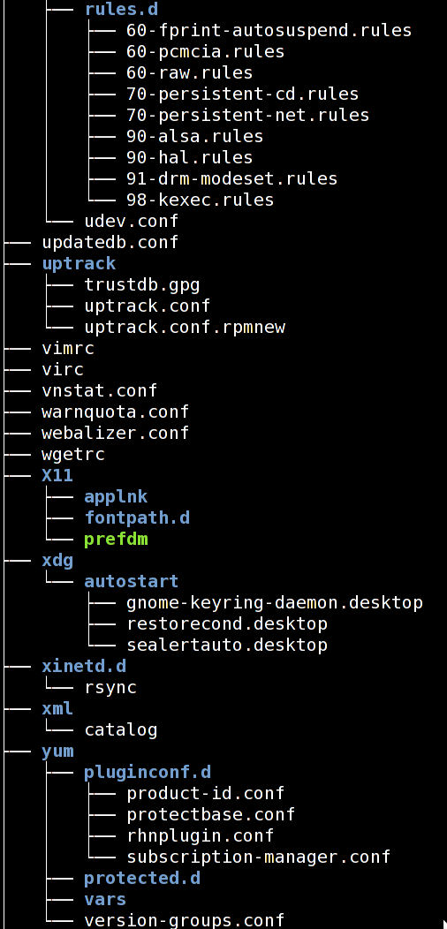
Fig.01: Linux tree Command To Display Structure of Directory Hierarchy

Here is a list of all options supported by the tree program:
-a All files are listed.
-d List directories only.
-l Follow symbolic links like directories.
-f Print the full path prefix for each file.
-i Don't print indentation lines.
-q Print non-printable characters as '?'.
-N Print non-printable characters as is.
-p Print the protections for each file.
-u Displays file owner or UID number.
-g Displays file group owner or GID number.
-s Print the size in bytes of each file.
-h Print the size in a more human readable way.
-D Print the date of last modification.
-F Appends '/', '=', '*', or '|' as per ls -F.
-v Sort files alphanumerically by version.
-r Sort files in reverse alphanumeric order.
-t Sort files by last modification time.
-x Stay on current filesystem only.
-L level Descend only level directories deep.
-A Print ANSI lines graphic indentation lines.
-S Print with ASCII graphics indentation lines.
-n Turn colorization off always (-C overrides).
-C Turn colorization on always.
-P pattern List only those files that match the pattern given.
-I pattern Do not list files that match the given pattern.
-H baseHREF Prints out HTML format with baseHREF as top directory.
-T string Replace the default HTML title and H1 header with string.
-R Rerun tree when max dir level reached.
-o file Output to file instead of stdout.
--inodes Print inode number of each file.
--device Print device ID number to which each file belongs.
--noreport Turn off file/directory count at end of tree listing.
--nolinks Turn off hyperlinks in HTML output.
--dirsfirst List directories before files.
--charset X Use charset X for HTML and indentation line output.
--filelimit # Do not descend dirs with more than # files in them.

In FreeBsd command stat usage:
[root@nag2 ~]# /usr/bin/stat -f " File: '%N'%SY%n Size: %-15z Blocks: %-10b IO Block: %-6k %HT%nDevice: %7Hr/%-7Lr Inode: %-11i Links: %l%nAccess: (%Mp%Lp/%Sp) Uid: (%5u/%8Su) Gid: (%5g/%8Sg)%nAccess: %Sa%nModify: %Sm%nChange: %Sc%n Birth: %SB" -t '%F %T %z' .vimrc~
File: '.vimrc~'
Size: 490 Blocks: 4 IO Block: 4096 Regular File
Device: 32/65702 Inode: 21605 Links: 1
Access: (0644/-rw-r--r--) Uid: ( 0/ root) Gid: ( 0/ wheel)
Access: 2012-09-04 19:02:08 +0400
Modify: 2012-09-04 19:00:38 +0400
Change: 2012-09-04 19:02:17 +0400
Birth: 2012-09-04 19:00:38 +0400
[root@nag2 ~]#

http://npre.wordpress.com/2012/08/31/linux-like-stat-in-freebsd/

Linux-like stat in FreeBSD
1 Reply
The default output of the stat command in FreeBSD was completely different from what I got used to in Linux. For example:
linux% stat /boot/vmlinuz-linux
File: ‘/boot/vmlinuz-linux’
Size: 3269840 Blocks: 6416 IO Block: 1024 regular file
Device: 801h/2049d Inode: 12 Links: 1
Access: (0644/-rw-r--r--) Uid: ( 0/ root) Gid: ( 0/ root)
Access: 2012-08-28 23:35:55.000000000 +0300
Modify: 2012-08-26 11:19:01.000000000 +0300
Change: 2012-08-28 23:35:47.000000000 +0300
Birth: -
vs
freebsd% /usr/bin/stat /boot/boot0
1149243074 13 -r--r--r-- 1 root wheel 0 512 "Jul 12 18:52:22 2012" "Mar 2 10:39:17 2011" "Feb 11 16:24:47 2012" "Feb 11 16:24:47 2012" 4096 2 0 /boot/boot0
Found it hard to read, I made some use of the -f argument to get it uniformed. Here’s the alias I use and the new output:
freebsd% alias stat="/usr/bin/stat -f \" File: '%N'%SY%n Size: %-15z Blocks: %-10b IO Block: %-6k %HT%nDevice: %7Hr/%-7Lr Inode: %-11i Links: %l%nAccess: (%Mp%Lp/%Sp) Uid: (%5u/%8Su) Gid: (%5g/%8Sg)%nAccess: %Sa%nModify: %Sm%nChange: %Sc%n Birth: %SB\" -t '%F %T %z'"
freebsd% stat /boot/boot0
File: '/boot/boot0'
Size: 512 Blocks: 2 IO Block: 4096 Regular File
Device: 0/0 Inode: 13 Links: 1
Access: (0444/-r--r--r--) Uid: ( 0/ root) Gid: ( 0/ wheel)
Access: 2012-07-12 18:52:22 +0000
Modify: 2011-03-02 10:39:17 +0000
Change: 2012-02-11 16:24:47 +0000
Birth: 2012-02-11 16:24:47 +0000
Looks much better huh?

We can use ls instead command blkid!

[root@m1-hadoop-cs01t ~]# ls -1F /dev/disk/by-uuid/
1dba8a35-b4a0-415f-b589-74318cc39a89@
51d3302d-e2d3-416d-8e0e-aa742bbb357f@
66b9a1c6-d4c6-4cd0-82d2-3f0d85769e1b@
76d97290-a426-4b1e-bced-ca7b9d9a2a22@
b4b08a6a-d5e9-41c7-b2cc-937fd0c8e867@
dae4e282-21fa-4b8f-8664-14119803b3e4@
f249a937-8545-4651-b52b-f6f4f48c9825@
[root@m1-hadoop-cs01t ~]#

http://www.tecmint.com/sort-ls-output-by-last-modified-date-and-time/

Sort Files Based on Time and Date
5. To list files in a directory and sort them last modified date and time, make use of the -t option as in the command below:
$ ls -lt
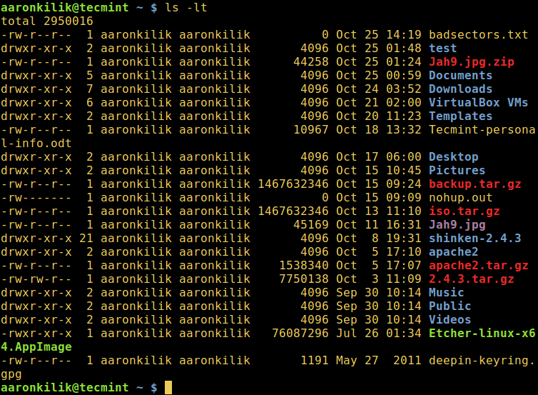
Sort ls Output by Date and Time
6. If you want a reverse sorting files based on date and time, you can use the -r option to work like so:
$ ls -ltr
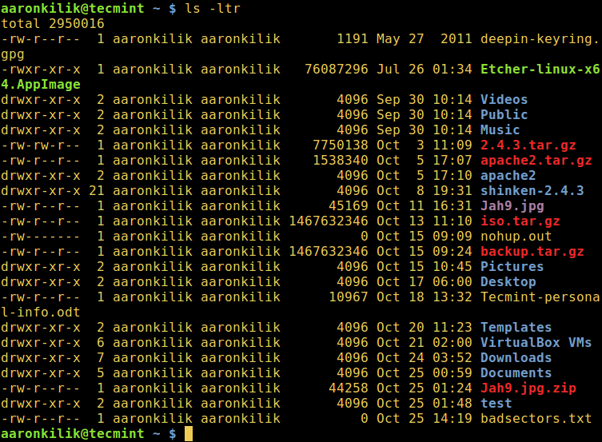
Sort ls Output Reverse by Date and Time
We will end here for now, however, there is more usage information and options in the ls command, so make it a point to look through it or any other guides offering ls command tricks every Linux user should know or use sort command. Last but not least, you can reach us via the feedback section below.

https://askubuntu.com/questions/209934/why-do-df-and-du-show-different-output

Why do df and du show different output?

When I execute the command df -h /tmp it says disk utilization is 100%, but when it try du -sh /tmp it says disk utilization is 2%.
I want to know why these commands shows different output, how these two commands work and what is the solution to this problem.
Context: /tmp is installed on it own file system. I am using Ubuntu 12.04 server edition on my VPS account. Due to this problem utilization of /tmp 100% according to df some programs complain about free space in /tmp.
command-line disk-usage
shareimprove this question
edited Jan 31 '14 at 23:40
asked Oct 31 '12 at 4:42

Nischay
1,40411221
add a comment

3 Answers
activeoldestvotes
up vote9down voteaccepted
du reports free space by scanning reachable inodes and calculating their size.
If a file is created, opened, and later deleted while it is still open, the program that opened it will continue to have access to the file, and writes and reads can be performed to that memory location on disk. du does not account for such open files whereas df does.
A simple restart should flush /tmp and solve your problem.
An alternative would be to scan open files and restart or kill the process that did not release the deleted files.
shareimprove this answer
answered Oct 31 '12 at 5:58

Mahesh
9,61443451
add a comment
up vote1down vote
Some files on root filesystem can be hidden behind a mount point. Files can be created under the mount point when corresponding device is not mounted, and when device is mounted again, files are not counted by du command. Very probable issue, when there is a big difference between du and df results.
shareimprove this answer
answered Aug 7 '16 at 20:00

Nick
111
- Bingo. This was the cause for me. – jdhildeb Feb 27 at 18:32
add a comment
up vote-1down vote
Make sure you sudo when running du. For instance, if you run du -hs /*, you won't see the real disk usage unless you add sudo.
shareimprove this answer

#
# Show only local filesystem.
#
[root@vm-postgresql03t /]# df -hTl
Filesystem Type Size Used Avail Use% Mounted on
/dev/mapper/vg_root-lvol0 xfs 20G 19G 797M 97% /
devtmpfs devtmpfs 3.9G 0 3.9G 0% /dev
tmpfs tmpfs 3.9G 0 3.9G 0% /dev/shm
tmpfs tmpfs 3.9G 17M 3.9G 1% /run
tmpfs tmpfs 3.9G 0 3.9G 0% /sys/fs/cgroup
/dev/sda1 xfs 253M 115M 139M 46% /boot
tmpfs tmpfs 783M 0 783M 0% /run/user/763
tmpfs tmpfs 783M 0 783M 0% /run/user/816
tmpfs tmpfs 783M 0 783M 0% /run/user/525
[root@vm-postgresql03t /]#

https://www.tecmint.com/dutree-analyze-disk-usage-in-linux/

dutree – A CLI Tool to Analyze Disk Usage in Coloured Output
by Aaron Kili | Published: April 17, 2018 | April 17, 2018
Download Your Free eBooks NOW - 10 Free Linux eBooks for Administrators | 4 Free Shell Scripting eBooks
dutree is a free open-source, fast command-line tool for analyzing disk usage, written in Rust programming language. It is developed from durep (disk usage reporter) and tree (list directory content in tree-like format) command line tools. dutree therefore reports disk usage in a tree-like format.
Read Also: Agedu – A Useful Tool for Tracking Down Wasted Disk Space in Linux
It displays coloured output, depending on values configured in the GNU LS_COLORS environment variable. This env variable enables for setting the colours of files based on extension, permissions as well as file type.

dutree Features:
- Show the file system tree.
- Supports aggregating of small files.
- Allows for comparing different directories.
- Supports excluding of files or directories.

How to Install dutree in Linux Systems
To install dutree in Linux distributions, you must have rust programming language installed on your system as shown.
$ sudo curl https://sh.rustup.rs -sSf | sh
Once rust installed, you can run the following command to install strong>dutree in Linux distributions as shown.
$ cargo install --git https://github.com/nachoparker/dutree.git
After installing dutree, it uses environment colors according to the variable LS_COLORS, it has the same colors ls --color command that our distro has configured.
$ ls --color
The simplest way of running dutree is without arguments, this way it shows a filesystem tree.
$ dutree
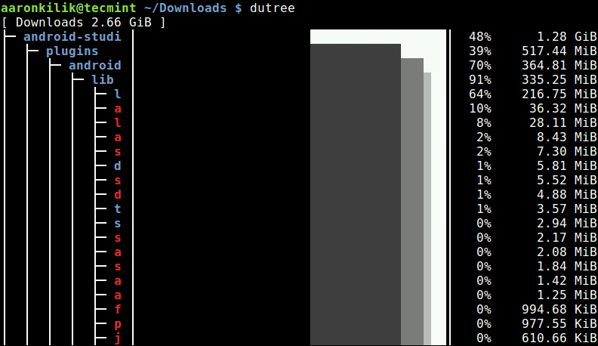
Linux Filesystem Disk Usage
To display real disk usage instead of file size, use the -u flag.
$ dutree -u
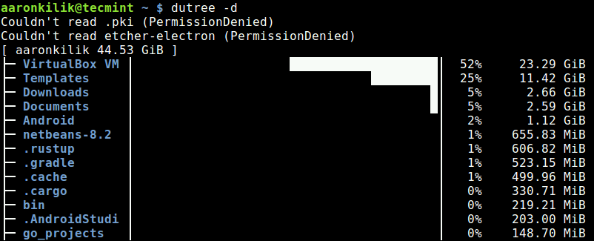
Show Linux Disk Usage

Show Directories in Depth
You can show directories up to a given depth (default 1), using the -d flag. The command below will show directories up to a depth of 3, under the current working directory.
For example if the current working directory (~/), then display size of ~/*/*/* as shown in the following sample screenshot.
$ dutree -d 3
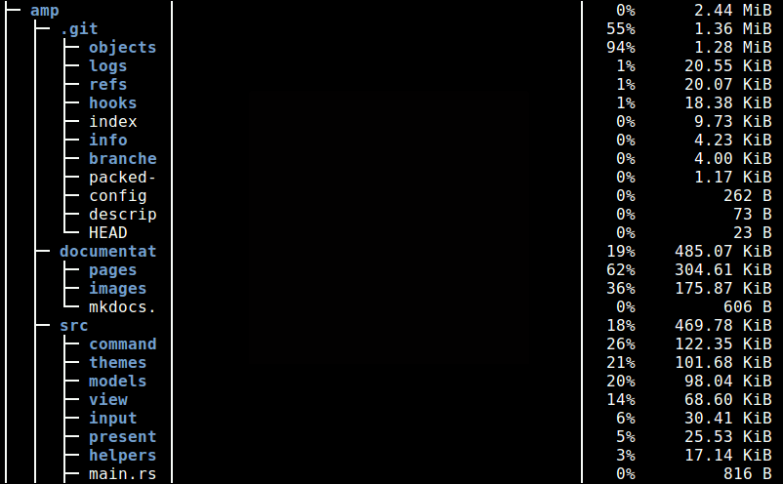
Show Directories in Depth Disk Usage

Exclude Files or Directories in Output
To exclude matching a file or directory name, use the -x flag.
$ dutree -x CentOS-7.0-1406-x86_64-DVD.iso
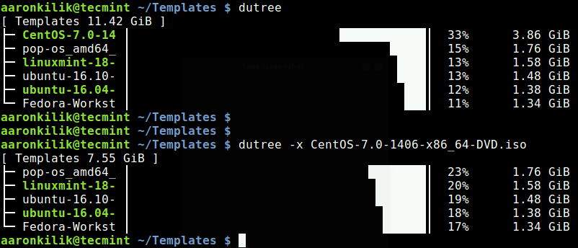
Show Disk Usage with Exclude Filename
You can also get a quick local overview by skipping directories, using the -f option, like so.
$ dutree -f
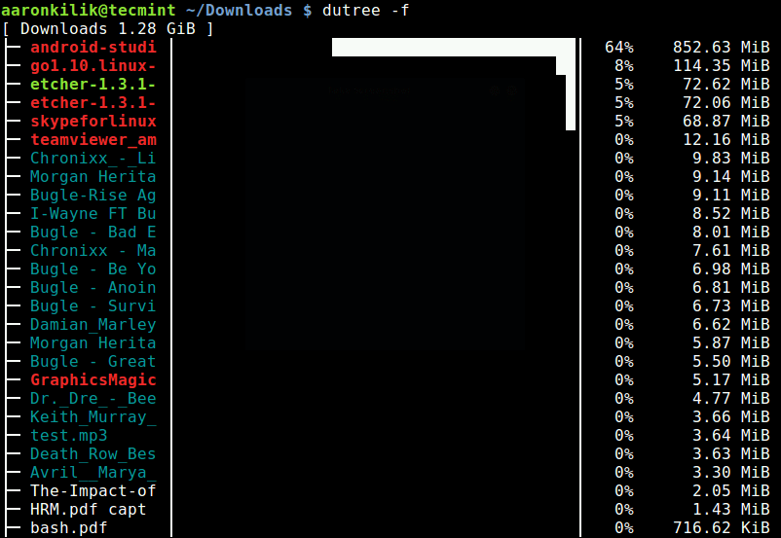
Quick Overview by Skipping Directories
A full summary/overview can be generated using the -s flag as shown.
$ dutree -s
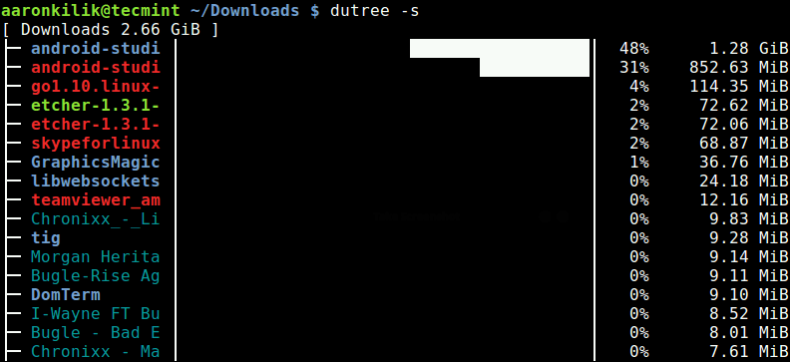
Linux Disk Usage Summary

Aggregate Small Files
It is possible to aggregate files smaller than a certain size, default is 1M as shown.
$ dutree -a
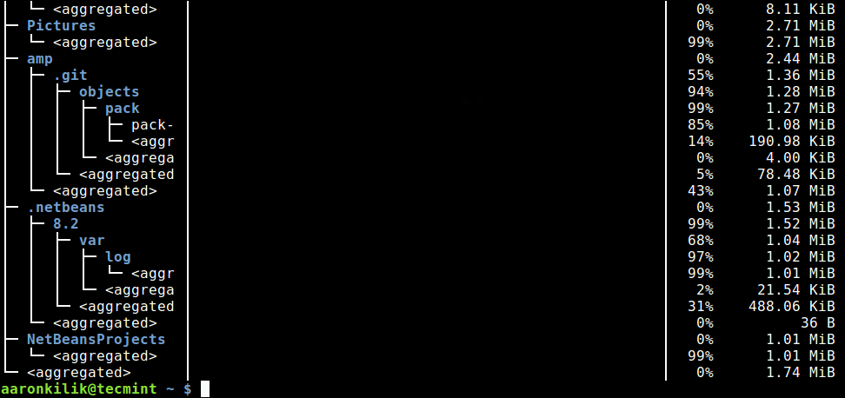
Aggregate Small Files

Exclude Hidden Files
The -H switch allows for excluding hidden files in the output.
$ dutree -H
The -b option is used to print sizes in bytes, instead of kilobytes (default).
$ dutree -b
To turn off colors, and only display ASCII characters, use the -A flag like so.
$ dutree -A
You can view the dutree help message using the -h option.
$ dutree -h
Usage: dutree [options] [..]
Options:
-d, --depth [DEPTH] show directories up to depth N (def 1)
-a, --aggr [N[KMG]] aggregate smaller than N B/KiB/MiB/GiB (def 1M)
-s, --summary equivalent to -da, or -d1 -a1M
-u, --usage report real disk usage instead of file size
-b, --bytes print sizes in bytes
-x, --exclude NAME exclude matching files or directories
-H, --no-hidden exclude hidden files
-A, --ascii ASCII characters only, no colors
-h, --help show help
-v, --version print version number
dutree Github Repository: https://github.com/nachoparker/dutree
dutree is a simple yet powerful command-line tool to show file size and analyze disk usage in tree-like format, on Linux systems. Use the comment form below to share your thoughts or queries about it, with us.

